.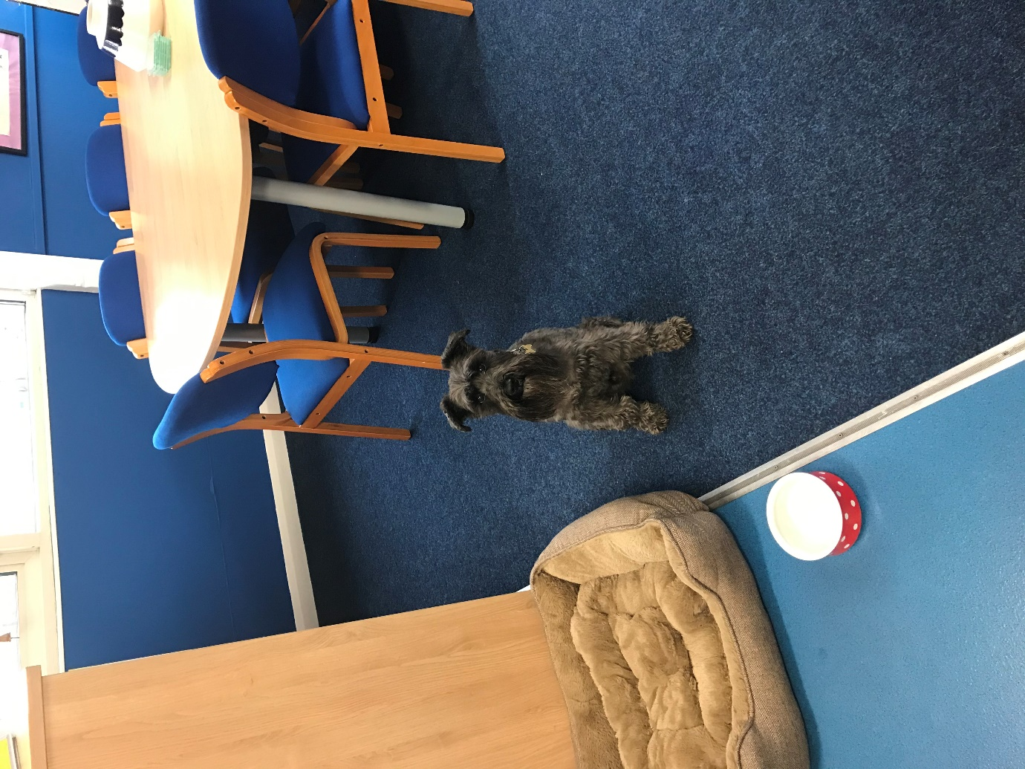

George- first day at school.
I met some children today and William and Caiden took me for a walk and gave me a biscuit. The children were hunting for Easter eggs but I cannot eat chocolate as it makes me poorly. I had great fun fetching a ball and then I went back to the office for a sleep. School is exhausting. But I love it.

