Misterton Primary and Nursery School Newsletter

Developing into a Take Care School

24th January 2025

Dear Parents and Carers,
Wellbeing Week
Last week we focused on Wellbeing and an aspect of this called Take Care.
The children learnt what it is to Take Care of each other, the school environment, their work and ourselves. We are forming a definition for each of these and would welcome your ideas.
Cuppa with the Head will focus on this on the 31st January, I would love you to join our assembly where the children share their Take Care Work and then join me for a cup of tea so I can share what we are doing and get your ideas. Please let me know if you can join me through the office.
The displays showcase the Take Care work from last week
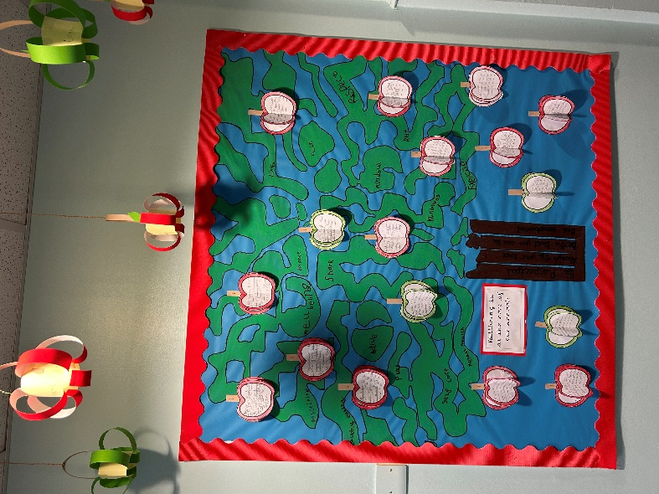
Year 1 Amazing Apples with Wellbeing at the Core

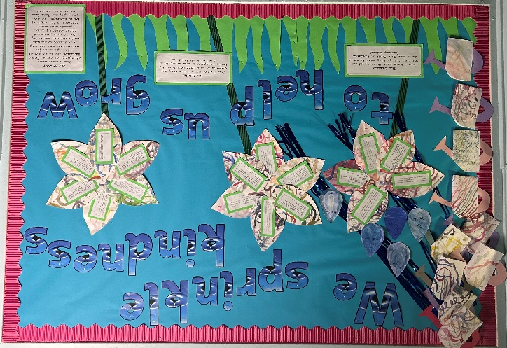

Year 2 Sprinkling kindness to help us grow

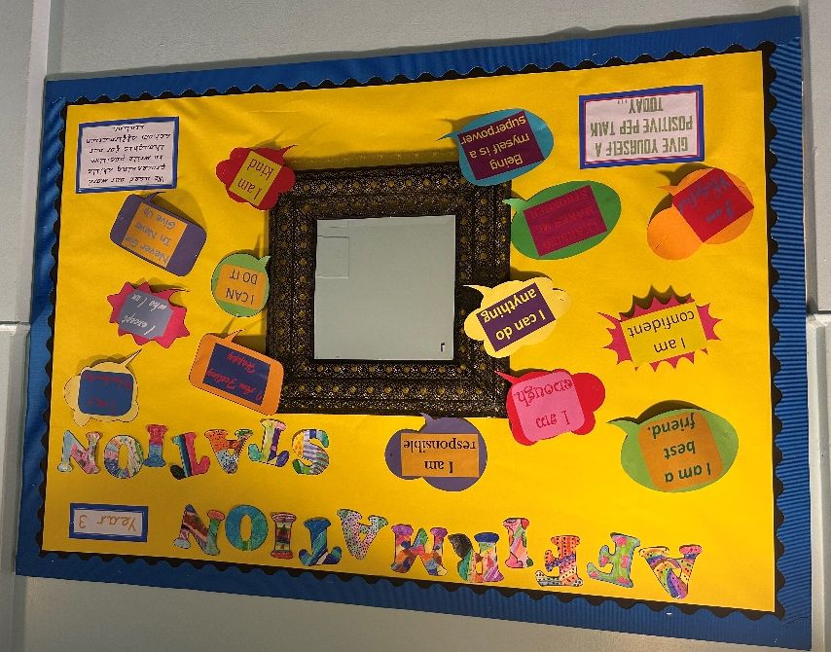

Year 3 with their Affirmation Station

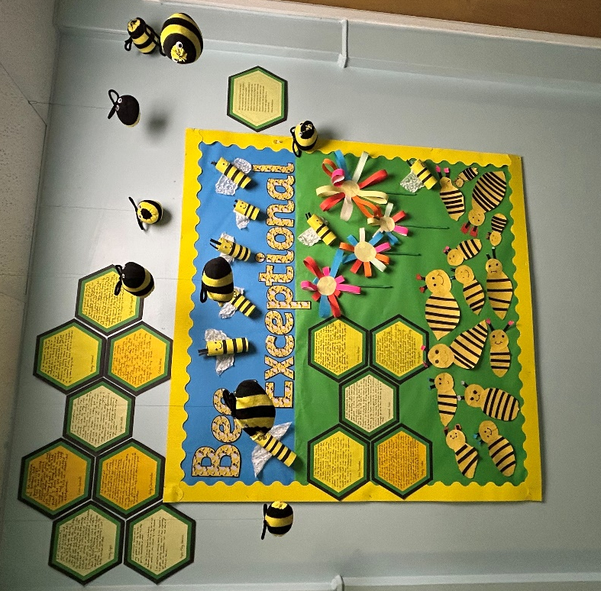

Year 4 who’s writing shows us, exactly what Bee Exceptional means

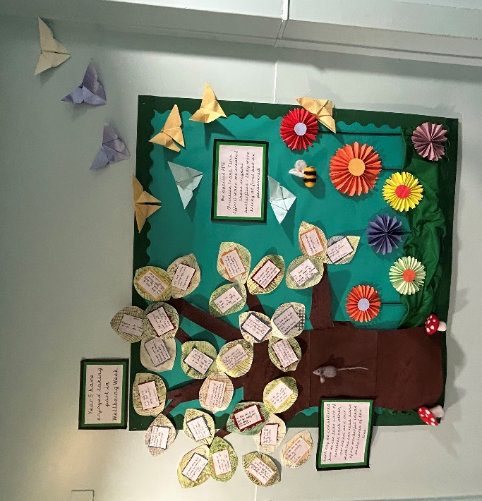

Year 5 practicing PITE (Practice, input, time and effort making origami butterflies and writing how we can Take Care

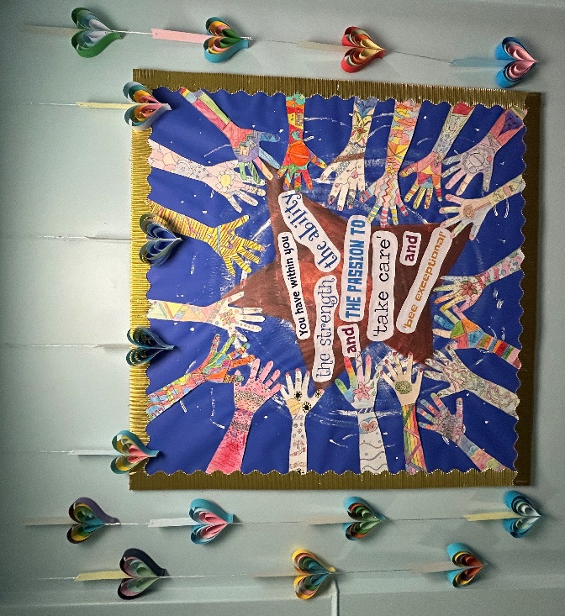

Year 6 finding self-belief in Take Care and Bee Exceptional

Kind regards
Mrs Jane Cappleman-Jackson

Headteacher

