Newsletter 6th September 2024

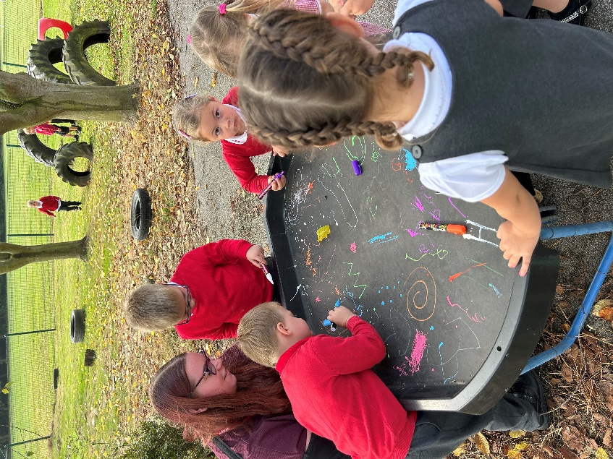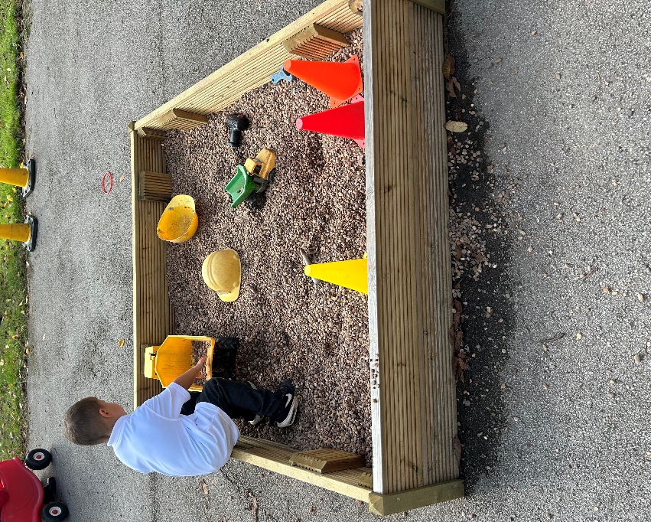

It has been a pleasure spending time with your children again and hearing about their summer holidays but also about their hopes for the new school year. I have spent time in each class this week and the children are focused on their learning and speak about how happy they are to be back seeing their friends and finding out about new learning. The learning buzz around school is so lovely.

The children look incredibly smart and are proud wearing their uniforms. They have settled back into school positively and are trying to make themselves and their learning teams proud.

Swimming
Swimming starts on the 13th September for Years 3 and 4. Year 4 will swim at 1.45pm and Year 3 at 1pm
Any parents, who are able to support their child’s class, please contact the teacher and a DBS can be arranged if you do not already have one with the school.
Swimming kit is a swimming costume or fitted shorts baggy swim shorts are not allowed. Earrings and goggles can only be worn if a form has been completed that we can send to the LA for their records.

Children need to remove earrings for PE and these needs to be done by themselves.

Clubs
All Nursery lunch hour and afternoon sessions, breakfast club & after school clubs are to be booked by the Sunday evening for the following week. Any additional requirements need to go through the school office. Breakfast Club doors open at 8am and breakfast is available until approximately 8.20am.

Dates.
Times for certain events to follow
September
9th10th11th 12th – Bikeability year 5
9th – 2pm – 3pm FS1 new starters stay and play
10th – 9.30am – 11.30am FS1 new starters stay and play
13th - Swimming starts
16th 17th 18th 19th – Bikeability year 5 & 6
19th – Year 5 trip to Perlethorpe
26th – Individual photographs
30th – Flu Immunisation Reception – Year 6
30^{th -} Parents Evening
October
1st – Parents Evening
4th – INSET DAY – School Closed
9th – Harvest Festival
14th – Non-Uniform Day for Christmas Fayre donations
21st October – 1st November Half Term

November
4th – Spooky Stories
7th – Book & Biscuits
13th – Olympic Day
26th – Big Talk Education

December
2nd – Christmas Craft afternoon
3rd – Christmas Fayre
9th - Christingle
12th – Christmas Dinner
19th Awards Assembly
20th Party Day

Kindest regards
Mrs Jane Cappleman-Jackson

Headteacher

